**Requirement Collection and Analysis**

**Definition**

(Wikipedia) In systems engineering and software engineering, requirements analysis focuses on the tasks that determine the needs or conditions to meet the new or altered product or project, taking account of the possibly conflicting requirements of the various stakeholders, analyzing, documenting, validating and managing software or system requirements.

Requirements analysis is critical to the success or failure of a systems or software project. The requirements should be documented, actionable, measurable, testable, traceable, related to identified business needs or opportunities, and defined to a level of detail sufficient for system design.

**What to submit for Requirement Collection and Analysis?**

* Stakeholder Identification
  + Myself(Steven Moody); being made for family use (Mother, father, Sister, and girlfriend are clients); open for download by anyone with IOS device
* Requirement Lists for Requirement Specifications
  + Fully functional IOS application that includes specifically:
    - A functional home menu with “leaderboard”, “Options”, and “game start” buttons
    - A background that is neutral and appealing within the menu
    - The ability to choose difficulty
    - The ability to change card background
    - The ability to start over once a game has completed/no more moves remain
    - The ability to input name associated with each high score
    - The ability to Reset the Leaderboard if needed
  + Major goals/tests associated with the above requirements specifications include:
    - Client will download a functional IOS application of “Devils Grip” and will test that each feature listed above performs as expected. See Use Cases for a list of how these tests will be performed.
* Use cases
  + A functional IOS application
    - Client(s) will download game to IOS (Apple) capable device, upon completion will start the application and ensure they are brought to the home screen
  + A functional home menu with “leaderboard”, “Options”, and “game start” buttons
    - Clients(s) will start the IOS application and upon loading of the home screen will be presented with three SELECTABLE buttons. The first will be “Play”, the second will be “Options”, and the third will be “Leaderboard”
  + A functional PLAYABLE game
    - Upon accomplishing the above use cases, Client(s) will select the “Play” button at which time they will be brought to a new screen/view where cards will be shuffled/dealt and the player then can begin playing “Devils Grip” following the constraints (rules) of the game.
  + The ability to input name associated with each high score
    - Upon completion of the above Use Cases, once a game has been successfully finished or no further moves remain, Client(s) will be given the option to enter a 3 character high score name to be placed on the “Leaderboards” if applicable
  + The ability to start over once a game has completed/no more moves remain
    - Upon completion of the above Use Cases, Client(s) will be given the option to either begin a new game or return to the home screen menu
  + The ability to choose difficulty
    - At the home screen menu, Client(s) will select the “Options” button and when brought to a new screen will be allowed to choose the difficulty in which they want to play the game at
  + The Ability to Reset Leaderboard
    - At the home screen menu, Client(s) will select the “Options” button and when brought to a new screen will be allowed to reset the leaderboard
  + A background that is neutral and appealing within the menu
    - Upon loading into the application, Client(s) will be greeted by a background that is appropriate based a background of their choosing
  + The ability to change card background
    - At the home screen menu, Client(s) will select the “Options” button and when brought to a new screen will be allowed to choose the rear-facing card background of their liking based on the backgrounds the Client deems appropriate
  + 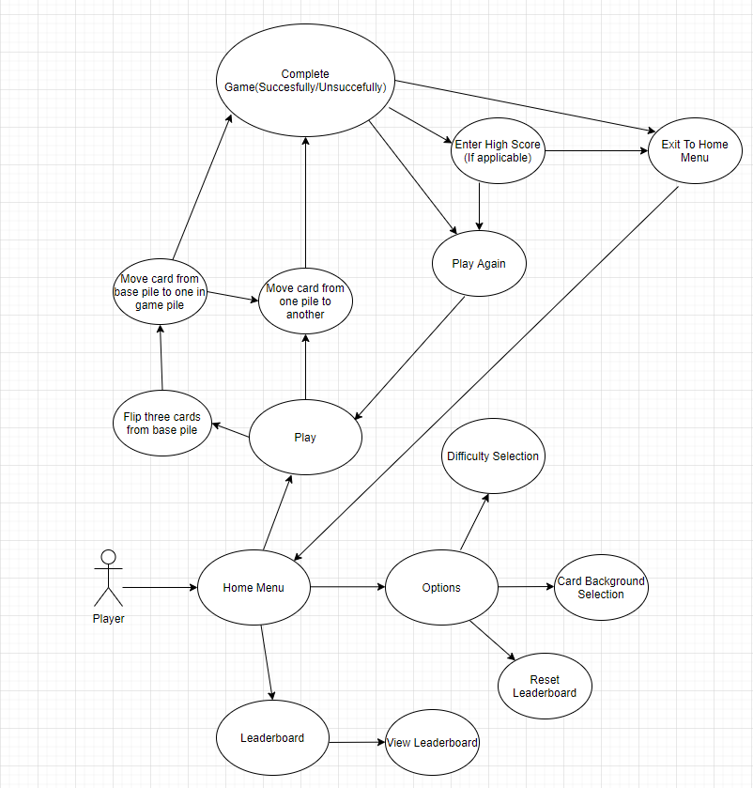Sequence Diagram for “Devils Grip” application